**STOCK management system**

**Project Abstract**

**Version 1.0**

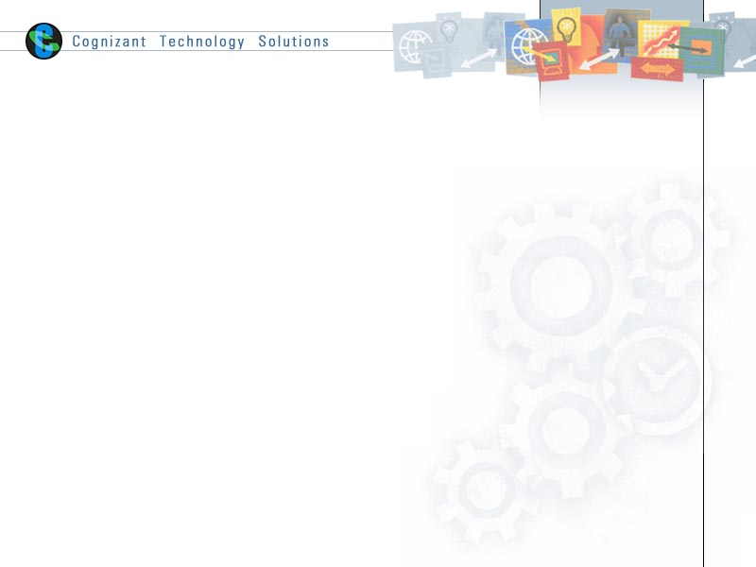

|  |  |  |  |
| --- | --- | --- | --- |
|  | Prepared By / Last Updated By | Reviewed by | Approved By |
| Name | Hemadharshini S | <Trainer/Project Governance Representative/Cohort Mentor to fill> | <Trainer/Project Governance Representative/Cohort Mentor to fill> |
| Role |  |  |  |
| Signature |  |  |  |
| Date |  |  |  |

Table of Contents

1.0 Purpose of this document 4

2.0 Business Case 4

2.1 Problem Definition 4

2.2 Alternative Solution 5

2.3 Background 5

2.4 Proposed Solution 5

2.5 Project Implementation 6

2.5.1 Support 6

2.6 Risks 6

3.0 Appendices 7

3.1 Glosary 7

3.2 Others 7

4.0 Terms & Conditions 8

5.0 Change Log 8

# 1.0 Purpose of this document

This document provides an overview of the business need and the solution that can be provided to fulfil the objective.

# Business Case

# Executive summary

The system aims to automate stock operations, improving efficiency by ensuring accurate stock availability, and preventing stockouts or excess stock. This project aligns with the business case of improving operational efficiency and user satisfaction in the Stock Management System (SMS).

# 2.1 Problem definition

The problem with the current stock management process can be defined in detail as follows:

* **Problem Stock:** Perishable and fragile stock need specialized plans for care and storage. And high-value inventory needs specific loss-prevention strategies and inventory controls.
* **Accurate Tracking**: Using manual inventory tracking procedures across different software and spreadsheets is time-consuming, redundant, and vulnerable to errors. Even small businesses can benefit from a centralized inventory tracking system that includes accounting features.
* **Demand Fluctuations:** Customer demand is constantly shifting. Keeping too much could result in obsolete inventory you’re unable to sell, while keeping too little could leave you unable to fulfill customer orders. Order strategies for core items, as well as technology to create and execute an inventory plan, can help compensate for changing demand.
* **Outdated Processes:** Keeping too much stock on hand can be as problematic as having too little. Overstock impacts business cash flow and leads to stock related problems, such as storage and loss.

# 2.2 Alternative solution

* **Just-in-Time (JIT) Stock Control:** Just-in-Time (JIT) is a lean inventory management method aiming to receive goods only when needed for production or order fulfilment. JIT allows warehouses to operate with leaner inventory levels by minimizing inventory holding and storage costs.
* **First-In, First-Out (FIFO):** [FIFO](https://datapel.com/fifo-and-lifo-inventory-methods/) is a stock rotation strategy where the oldest inventory items are sold or used first. Implementing FIFO helps prevent inventory obsolescence and spoilage, ensuring products are consumed or sold before expiration.
* **Vendor-Managed Inventory (VMI):** [Vendor-Managed Inventory (VMI)](https://datapel.com/vendor-managed-inventory-vmi/) is a collaborative approach where the supplier manages the stock levels at the customer’s warehouse. Suppliers monitor stock levels and replenish stock as needed.

# Introduction

The project aims to develop a Stock Management System (SMS) that efficiently manages inventory, optimizes stock levels, control costs, prevents stockouts, tracks goods movement, and minimizes product wastage. It contributes to overall business efficiency.

**2.3 Background**

A stock control system, also known as an inventory management system, is a carefully designed framework used by businesses and organizations to keep track of and manage their stock. This system is crucial for ensuring that goods and products move smoothly through the different [stages of the supply chain](https://datapel.com/supply-chain-strategy-for-resilience/), which ultimately affects how well the company runs, how much money it makes, and how happy its customers are.

The main goal of a stock control system is to find the right balance between how much stuff is available and how much is needed. This means keeping a very accurate record of what’s in stock, predicting when people will want to buy more, and using smart methods to make sure there’s not too much or too little inventory.

# 2.4 Proposed solution

The aim of the proposed system is to develop a system of improved facilities. The proposed system can overcome the overall limitations of the existing system. The system provides proper security and reduces manual work. This overall increase management productivity, eliminates paperwork, reduce manpower and prove to be very economical in the long run.

# 2.5 Project Implementation

 The implementation of a stock management system such as a system plays a crucial role in the supply chain by controlling the movement and storage of materials within a warehouse, as well as processing associated orders.

# 2.5.1 Support

* **Requirement Gathering:** Collaborate with stakeholders (warehouse managers, inventory staffs, etc.) to gather detailed requirements. Understand the types of items to be managed (raw materials, finished goods, etc.), storage locations, and any specific business rules.
* **System Testing:** Design the architecture of the stock management system. Consider factors like scalability, security, and integration with other systems. Define the database schema for storing item details, stock levels, and transaction history.
* Testing and Quality Assurance: Rigorously test the system to ensure it meets requirements. Address any identified issues promptly.
* **Deployment:** Deploy the stock management system to the production environment. Train the warehouse staff on using the system effectively.
* **Maintenance and Support:** Provide ongoing maintenance and support. Monitor system performance, address bugs, and make necessary enhancements.

# 2.6 Risks

* **Technical Risks**: These include risks related to software development such as potential bugs, system crashes, or data corruption. There could also be risks associated with integrating the new system with existing systems.
* **Data Integrity and Accuracy**: Inaccurate or corrupted data can lead to incorrect stock levels, order fulfillment issues, and financial losses.
* **Integration Challenges**: Integrating the stock management system with existing systems (e.g., accounting, sales, and e-commerce platforms) can be complex.
* **Security Vulnerabilities**: Unauthorized access, data breaches, or cyberattacks can compromise sensitive stock information.
* **Performance Bottlenecks**: Slow database queries or inefficient indexing can impact overall system performance.
* **User Acceptance Risks**: There is a risk that end users (admin and users) may not accept or adapt to the new system.
* **Training Risks**: There could be risks associated with training staff to use the new system effectively.
* **Maintenance Risks**: Over time, the system will require updates and maintenance. There is a risk that these could be more costly or time-consuming than anticipated.

# 3.0 Appendices

## 3.1 Glossary

|  |  |
| --- | --- |
| **Acronyms** | **Definitions** |
| SMS | Stock Management System |
| Add Stock | A stock can be added to the cart. |
| Show Stock | View the availability of stock in the store. |
| Show the Stock based on ID | View the stock availability for one row in the table based on their Customer ID. |
| Update Stock | Changing the name of the stock in the table. |
| Delete Stock | Delete the stock from the table using the customer ID. |

## 

## 

## 3.2 Other

**System Integration:** The stock management system should be designed to integrate with other existing systems in the stock, such as add, view, update, and delete. This integration will provide a seamless user experience and ensure that all resources are easily accessible.

**User Interface Design:** The system should have an intuitive and user-friendly interface. This will make it easy for both inventory staffs and customers to use the system. The design should be responsive, ensuring accessibility on various devices like computers, tablets, and smartphones.

**Data Security and Privacy:** The system should adhere to the highest standards of data security and privacy. It should have mechanisms in place to protect sensitive information like customer contact details and address.

**Scalability:** The system should be scalable to accommodate the growth of the store. As the stock system expands its collection and member base, the system should be able to handle the increased load without compromising performance.

**Sustainability:** The system should be sustainable and have a low environmental impact. For example, by booking the products from online platform, the system can reduce paper usage and contribute to environmental sustainability.

# 4.0 Terms & Conditions

***Disclaimer: Please do not circulate or distribute this document outside of Cognizant Network, We have a Zero Tolerance Policy. Kindly adhere to 100% Compliance at all times.***

# 5.0 Change Log

*Please note that this table needs to be maintained even if a Configuration Management tool is used.*

|  |  |  |  |  |
| --- | --- | --- | --- | --- |
| Version Number | Changes made | | | |
| V<n.n> | *<If the change details are not explicitly documented in the table below, reference should be provided here>* | | | |
| Page no | Changed by | Effective date | Changes effected |
|  |  |  |  |
|  |  |  |  |
|  |  |  |  |
|  |  |  |  |